Practice steps:

Create a folder open with GIT

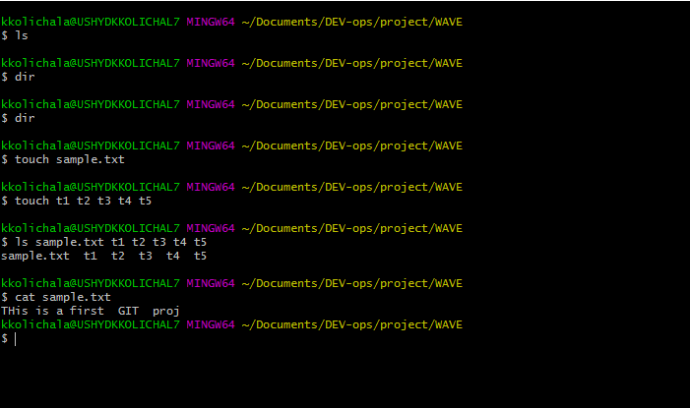

Content can be added using editors : “Vim, Nanao ,Atom”

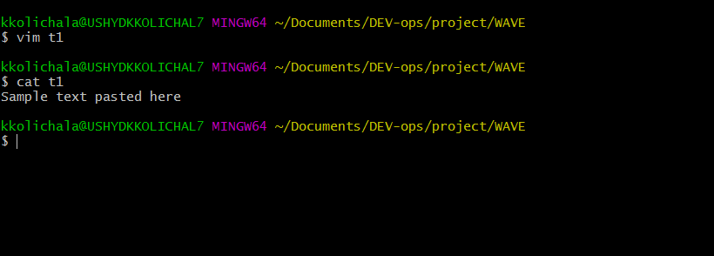

Nanao

In nanao - CTRl+X --- to save -> y 🡪 not to save N

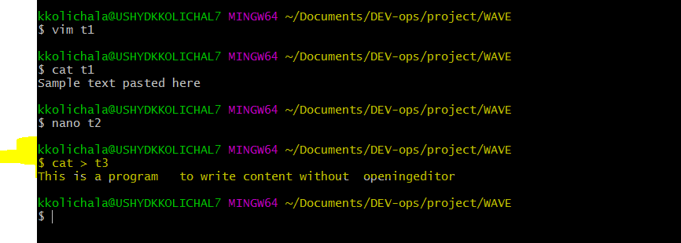

Cat> folder

Enter text

To end editor mode enter CTRL +D

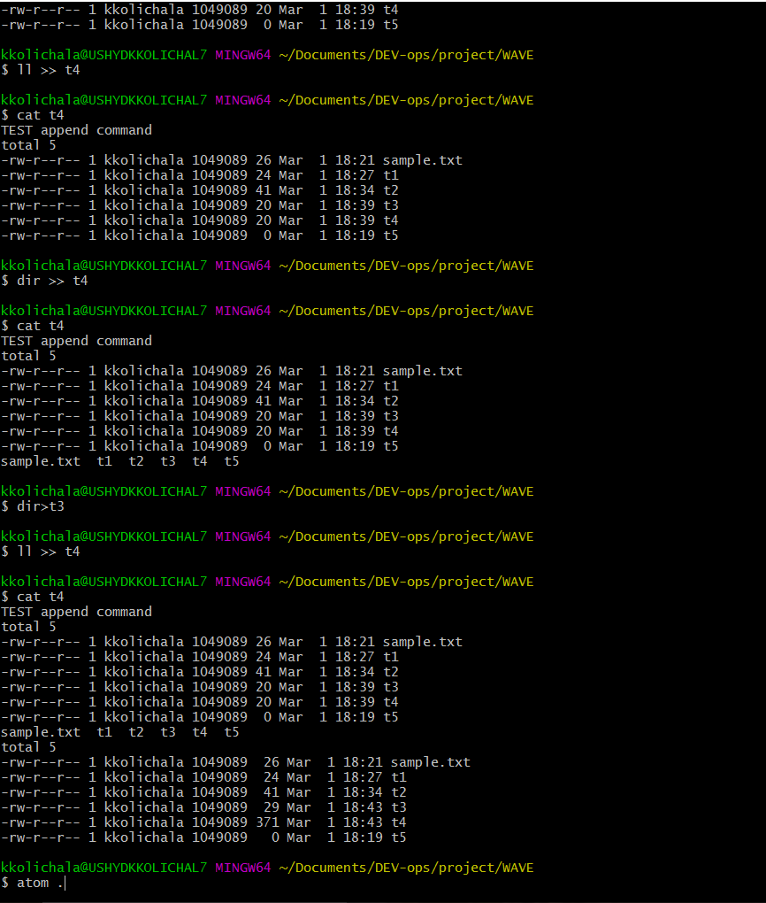

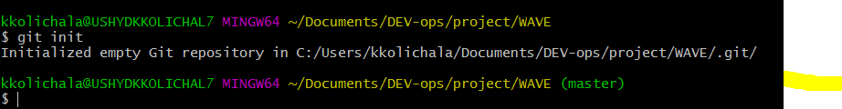

Master come only when a get instance of repository is created

How to declare a git file a s specific person

